COPPA Compliance for Log360 Cloud
Strengthen data protection and meet COPPA compliance with Log360 .
Region: USA | Type: Data Privacy, Government/Public Sector | Category: Compliance | Pricing: Free

Overview
The COPPA compliance extension in Log360 helps organizations meet the Children's Online Privacy Protection Act (COPPA), the US federal law enforced by the Federal Trade Commission under 16 CFR Part 312 by providing centralized log management, security monitoring, and compliance-focused reporting. The platform supports COPPA requirements for written information security programs, access control safeguards, annual risk assessments, security safeguard testing, data retention and secure deletion, third-party data handler assurance, and endpoint protection for systems handling children's personal information.
For Written Information Security Program, Log360 provides centralized log management, security monitoring, and compliance reporting to support program implementation. To address Security Safeguard Testing and Monitoring, the platform enables continuous security monitoring and automated testing of controls. The extension also supports Access Control and Authentication Safeguards by providing capabilities that monitors logon events, tracks privilege changes, enforces access policies, and detects unauthorized access attempts across Active Directory, Windows, Unix, and cloud environments.

Key Features
- Security Coordinator and Risk Assessment: Log360 supports risk assessment through vulnerability detection, threat analytics, and comprehensive audit reports.
- Data Retention Policy and Deletion Controls: Log360 tracks data lifecycle events, monitors file deletion activities, and audits disposal processes to ensure timely and secure data removal.
- Third-Party Data Handler Assurance: Log360 monitors third-party access patterns, API activity, and data transfer logs for external entity compliance.
- Data Collection and Consent Monitoring: Log360 monitors web server access logs, application events, and consent transaction workflows to verify that data collection complies with notice requirements.
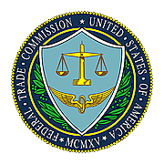
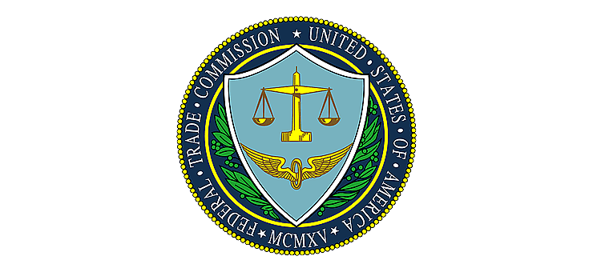

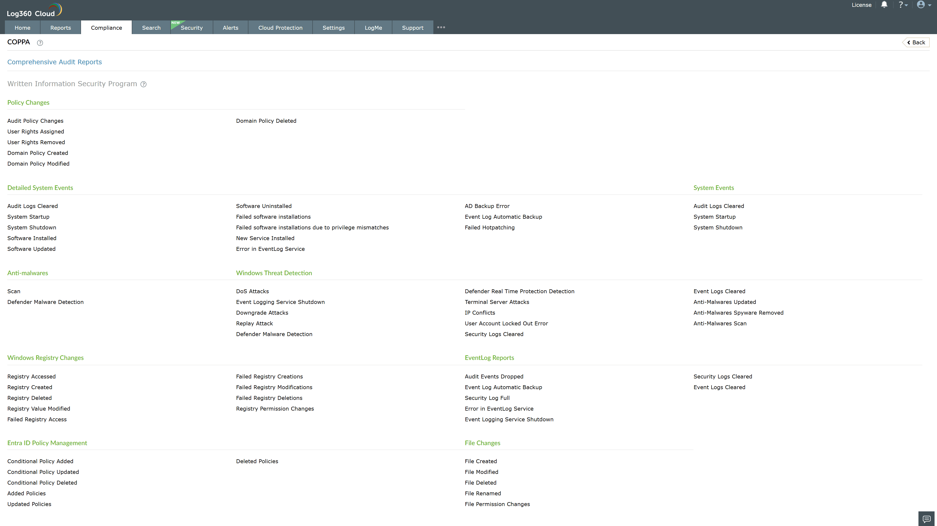
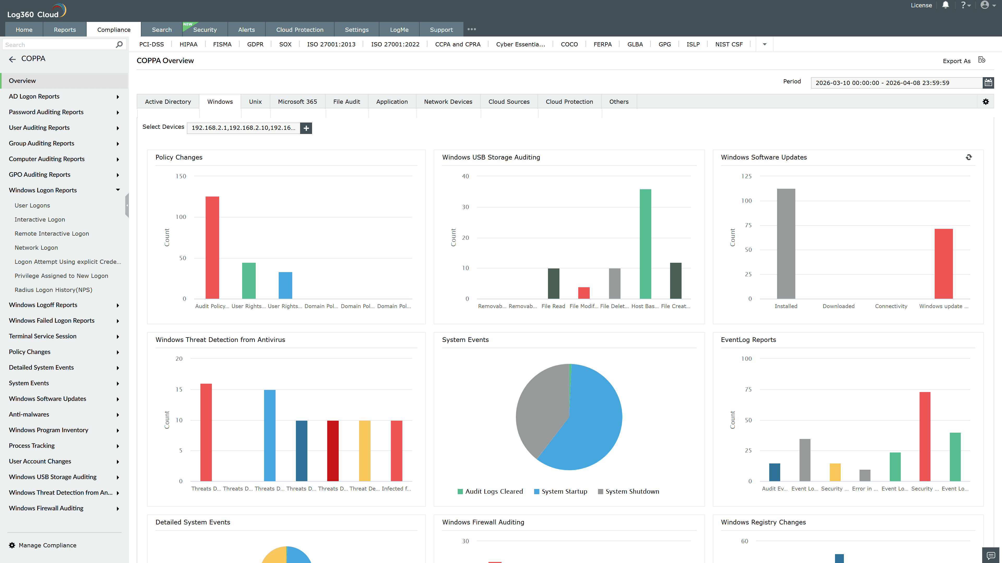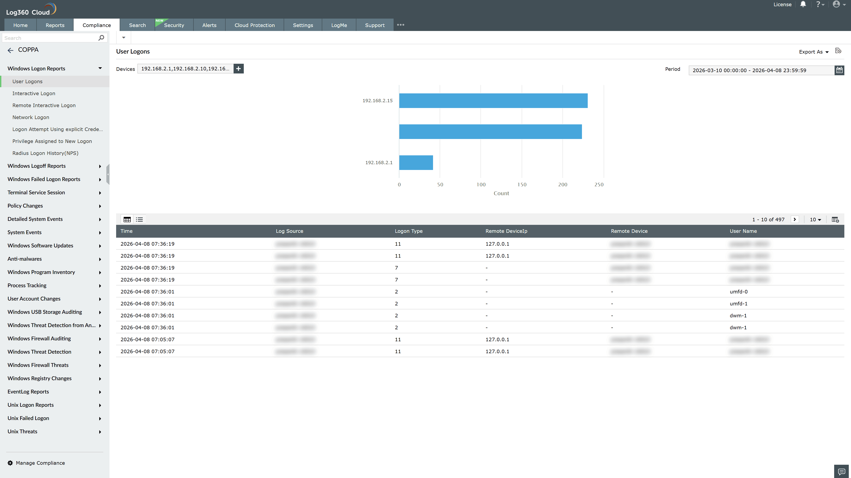
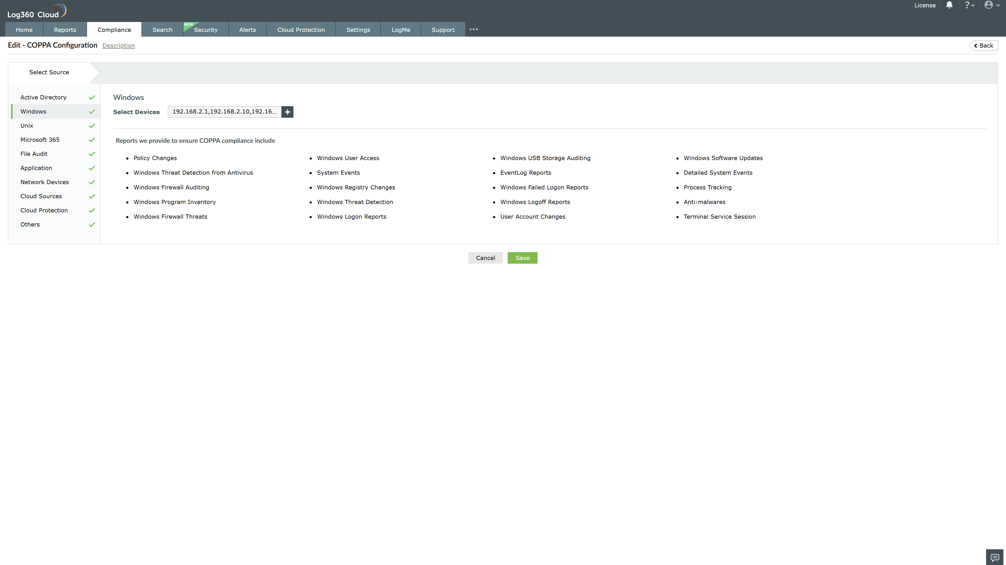
Valid Submission : Yes
Supported Editions : Free, Basic, Standard, Professional, MSSP
Help Document : https://www.manageengine.com/log-management/help/integrations/compliance-extensions.html
Help Video : Not provided
Tags : Log360, Compliance, Privacy monitoring, Data privacy, Regulatory compliance
Supported DCs : US, IN, JP, CA, AU, UK and EU
Privacy Policy:
Terms of Service:
Release Notes:
Predefined reports for the COPPA.

